University of Florence
International Sociological Association

Annual Conference of the Research Committee on Poverty, Social Welfare and Social Policy (RC19), International Sociological Association

Florence, Italy, 6-8 September, 2007

Poverty indicators in Palestine

Anwar Qabaja,

Jad Isaac

Hilmi S. Salem

Applied Research Institute-Jerusalem (ARIJ)
Bethlehem - Palestine

www.arij.org

June, 2007
Poverty indicators in Palestine

1. Country presentation

1.1. Historical and geographical background and population

Historical Palestine is located on the western edge of the Asian continent and the eastern extremity of the Mediterranean Sea. Its area covers 27,009 km² (PCBS). Historical Palestine was under the British Mandate between 1920-1948 while was committed to the idea of establishing a "Jewish National Home" in Palestine, as stipulated in the Balfour Declaration of November 1947. In 1947, the UN declared plan to partition Palestine into a Jewish state and an Arab stat. This eventually led to "the first Arab-Israel war" in 1948 after Britain's decision to withdraw. As a result of the war, Palestinian people have experienced military invasions, violence, settlement building on their land and the destruction of the Palestinian economy. The most important watershed was the Catastrophe (Nakba) of 1948, during which two thirds of the Palestinian people were expelled or fled from their homeland and almost 500 villages and towns were depopulated or destroyed. Their destination was to the West Bank, the Gaza Strip (the only parts of Mandate Palestine that did not fall under Israeli control after Israel established itself as a state in Palestine in 1948), and the neighbouring Arab countries (Jordan, Syria and Lebanon). Palestinians remain today in refugee camps outside their country.

From 1948 and until 1967, Jordan ruled the West Bank while Egypt administrated the Gaza Strip. In 1967, the West Bank (including East Jerusalem) and the Gaza Strip occupied by Israel (during the 1967-War) and have been, since then, referred to as the Occupied Palestinian Territory (OPT).

The OPT consists of two physically separated landmasses: the West Bank (including East Jerusalem) and the Gaza Strip. The OPT area covers 6,020 km², constituting 22% of the entire area of Historical Palestine "pre-1948 British Mandate Palestine". Almost four million Palestinians today (or 77.7% of those Palestinians remaining in Palestine; which forms 39.2% of the total Palestinians all over the World) live in the OPT. The remaining 1.1 million live in Israel. In Addition, six million Palestinians are refugees living in exile outside of Palestine all over the world (PCBS, 2006).

The two geographically parts of the OPT is separated by Israeli territory. The West Bank is 5,655 km² in area, and 130 km long, and ranges from 40 to 65 km in width. It lies between Israel to the west and Jordan to the east. The Gaza Strip is 365 km² in area, 45 km long and between 5 and 12 km wide. It borders Israel to the north and east, the Egyptian Sinai Peninsula to the south, and the Mediterranean Sea to the west. The Gaza Strip is mainly coastal plain and sand dunes along the Mediterranean, while the West Bank is more diverse, featuring four topographic zones. These are: The Jordan River Valley, the Eastern Slopes, the Central Highlands, and the Semi-Coastal Zone (UNICTAD).

The West Bank is divided into 11 governorates and districts, each of which is named after one of the main cities. The northern governorates comprises of Jenin, Tulkarem, Qalqilya, Nablus, and Salfet and Tubas Districts, while the central governorates comprise Jerusalem, Ramallah and Al-Bireh, and Jericho; while the southern governorates consist of Hebron and Bethlehem. The Gaza Strip is divided into five parts (governorates): Northern Gaza, Central Gaza, Deir El-Balah, Khan Yunis and Rafah (ARIJ, 2007) (see Map 1).
Map 1: Historical Palestine and OPT borders and Segregation Wall route
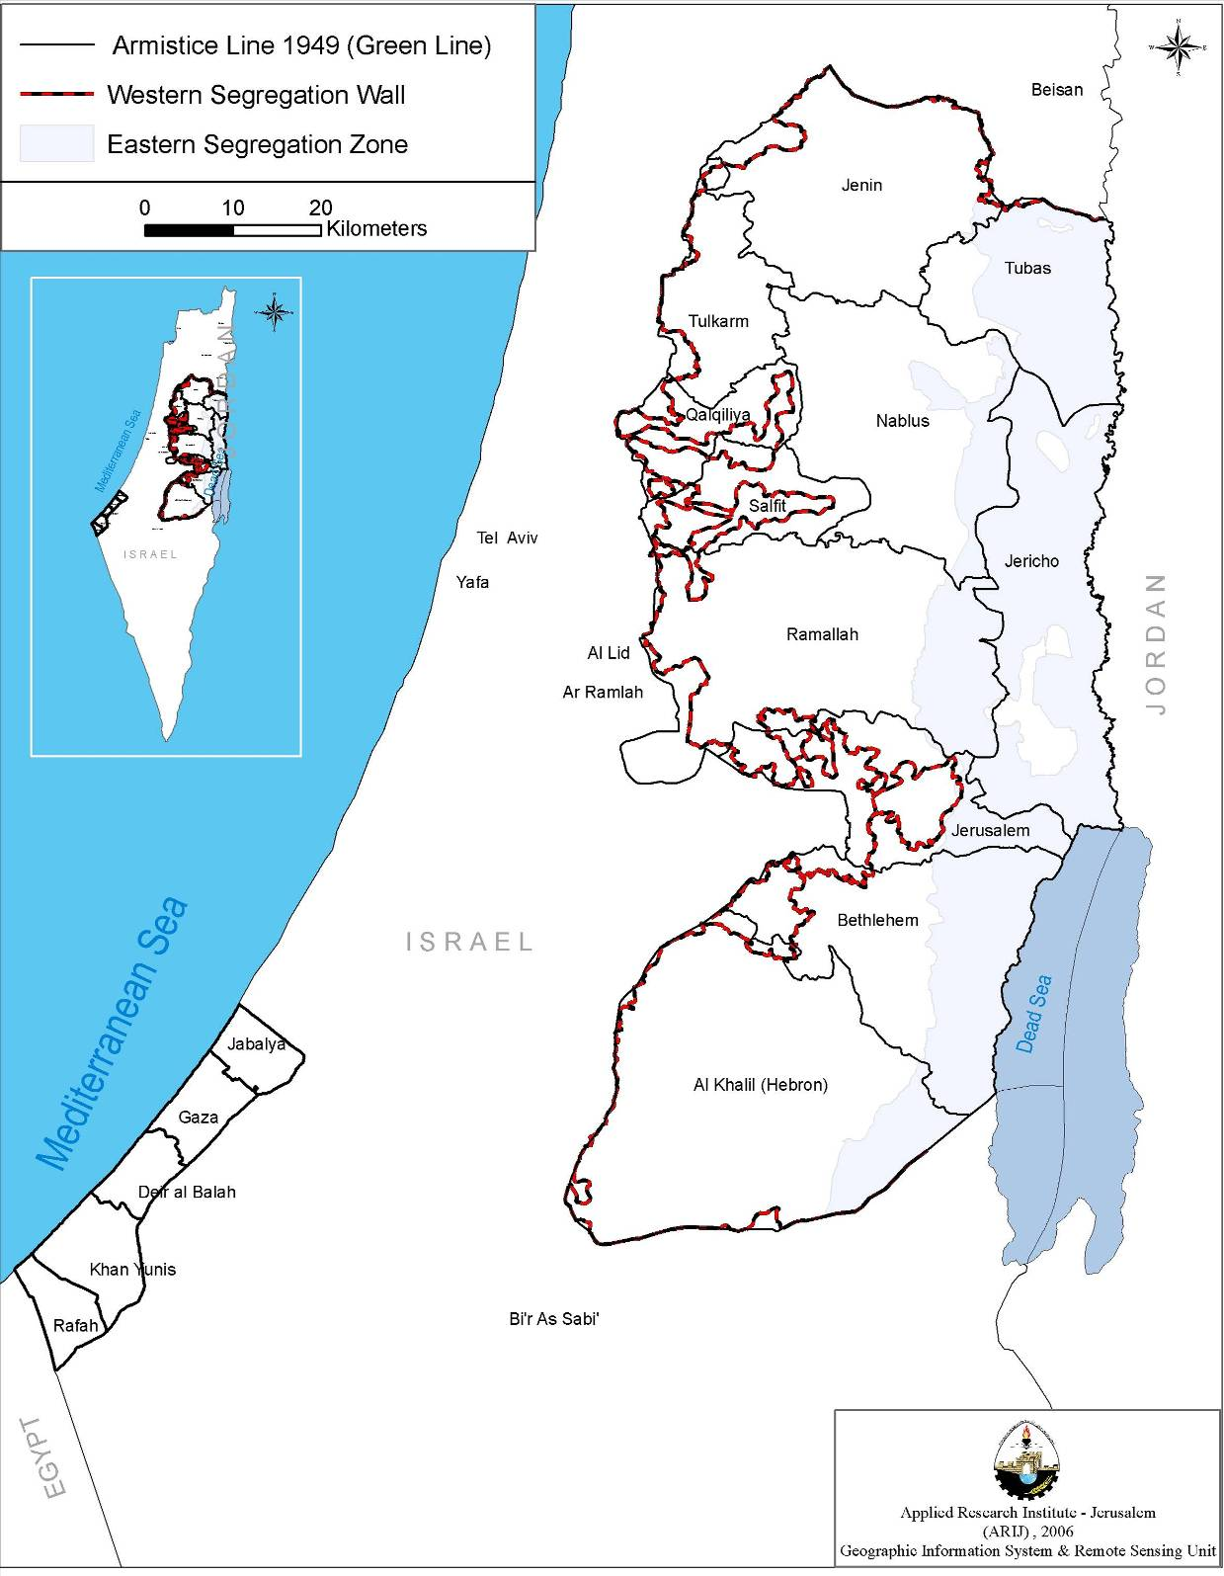
Source: ARIJ, GIS Unit, 2007

The population density differs markedly between the two parts. In the West Bank, it is 625 persons per km², whereas in the Gaza Strip, it is 6,593 persons per km² (PCBS, 2006).

The population of the OPT is estimated by the Palestinian Central Bureau of Statistics (PCBS) to have reached about 4 millions at the end of 2006, (39.2% of the total Palestinians all over the world); 2.5 millions (63%) in the West Bank and 1.5 millions (37%) in the Gaza Strip. According to the distribution of the population by governorates, the Hebron Governorate has the highest rate of population at 14% of the total population, followed by the Gaza Governorate (13%), the Jerusalem Governorate (10.5%). On the other hand, the Jericho Governorate has the lowest rate of population at 1.1%.

Almost 43.8% of the population in the OPT are registered as refugees as a result of the wars of 1948 and 1967, estimated 1.7 millions at the end of 2006; 714,000 (28.8%) in the West Bank and about one million (69.2%) in the Gaza Strip (see Table 1).

Table 1: Estimated Palestinian population in OPT by refugee's status and region (2006)
Region | Refuges Status
Region | Refugees | % | Non –Refugees | % | Total
OPT | 1,732,801 | 43.8 | 2,219,553 | 56.2 | 3,952,354
West Bank | 714,459 | 28.8 | 1,766,303 | 71.2 | 2,480,762
Gaza Strip | 1,018,342 | 69.2 | 453,250 | 30.8 | 1,471,592
Source: PCBS, 2006

According to the PCBS-2006 report, 45.7% of the population in the OPT is under 15 years; 43.9% in the West Bank and 48.8% in the Gaza Strip. The percentage of Palestinians who are above 65 years in the OPT is 3%. This figure reached 3.3% in the West Bank and 2.6% in the Gaza Strip.

The estimated number of males in the OPT at the end of 2006, is about 2 millions compared with 1.95 millions females, which the sex ratio of 102.8.

The Population natural increase rate is 3.3% in the OPT in 2006. This rate reaches 3% in the West Bank and 3.8% in the Gaza Strip, considerably higher than the world growth of 1.3%.

The population factor in the OPT is considered a genuine national resource, especially in view of the lack of available natural resources. Nevertheless, the OPT faces critical challenges in the area of human and population development, due to the circumstances of the Israeli Occupation and its legacy of unemployment, poverty and domination of natural resources, in addition to the high population's growth rate.

Table 2: Main demographic indicators in the OPT (2006)
Indicator | Year
Indicator | 1997 | 2006
Sex ratio | 101.9 | 102.8
Median age | 16.4 | 16.9
Crude Birth Rate | 42.7 | 36.7
Crude Death Rate | 4.9 | 3.9
Natural Increase Rate | 3.8 | 3.3
Total Fertility Rate | 6 | …
Life Expectancy at Birth  - Males  - Females | 70.2  71.7 | 71.7  73.2
Average Household Size | 6.4 | 6
Source: PCBS, 2006 … Data not available

1.2. Economic Background

The Palestinian economy has been intensely affected by the Palestinian-Israeli conflict. Since 1967, the Israeli Occupation has succeeded in turning the West Bank and the Gaza Strip into dependent economy and reservoir of cheap labour. The economy of the OPT has been "income economy" rather than a "production economy" making the OPT extremely vulnerable to the Israeli labour and goods markets.

With the establishment of the Palestinian National Authority (PNA) in 1994, following the signature of the Declaration of Principles (DOP) on September 1993 between the Palestine Liberation Organization (PLO) and Israel, Palestinians began assuming increasing administrative responsibilities and sovereignty over the civil aspects of the Palestinian life. Despite the complicated peace process, the Palestinian economy still lacks autonomy, national strategic control and a self-monitoring system. Restrictive measures imposed by the Israeli Occupation on Palestinian economic activities have created numerous obstacles.

Overall, Palestinian economic performance, following the Oslo Accords in 1993 and until 1997, was weak and vulnerable due to Israeli Occupation since 1967, characterized by negative growth rates, a decline in GDP, a decline in household incomes, a decline per capita income and a sharp increase in unemployment and a general broadening of poverty. All have posed serious challenges for the Palestinian economic sustainability. A variety of factors has contributed to this – most notably closures and other restrictions on the mobility of goods and people (effective control on borders, access to natural resources, and management of territory). As a result, the initial experience of the peace process for many Palestinians was declining the living standards. The Palestinian economy was and remains vulnerable and heavily dependent on the Israeli economy. 75% of Palestinian imports transits through or originates in Israel, while the Israeli market accounts for 90% of Palestinian exports (UNICTAD, 2005).

After 1997, the OPT experienced a modest economic growth, including rising per capita incomes and employment growth, despite the high population growth rates of 3.5%. The unemployment rate fell to 12.4% in 1999. With increasingly effective tax collection and economic growth, the PNA tax revenues almost covered all current expenditures.

With the beginning of the Second Intifada (Uprising) in September 2000 following the failure of the negotiations at Camp David and Taba, economics conditions have deteriorated in the OPT, marked that the Israeli Occupation Forces (IOF) re-occupied Palestinian Territory. Curfews, network of checkpoints, roadblocks and severe economic and social consequences have been inflicted daily on the Palestinian population in the OPT. The intensification of comprehensive closures and the resultant restrictions placed on the movement of people and goods (not just within the OPT but between the West Bank, the Gaza Strip and Israel), have had the double-edged effect on both local economies and the export of Palestinian goods to the world.

Since that time, all economic indicators had been negatively affected, in addition to the unprecedented physical destruction and losses. The World Bank estimates that Palestinian Gross Domestic Product (GDP) in 2004 was 20% lower than in 1999 and GDP per capita was lower by 37%. On the other hand the total accumulated physical damage inflicted between October 2000 and June 2004 is estimated at over US$ 2.2 billions. This situation has resulted in a near collapse of the Palestinian economy, high unemployment and a sharp increase in poverty (World Bank, 2005).

The median family income has dropped by 40% compared to pre-2000 levels, to which the Palestinian population has responded by resorting to coping mechanisms such as reducing their consumption levels, using personal savings, selling off assets, delaying payments and incurring debt. Donors responded by doubling annual disbursements and shifting the bulk of their assistance from development into emergency support. The PNA’s fiscal accounts had also been put in severe disarray during the Intifada, as PNA revenues collapsed when Israel decided to withhold tax revenues collected on behalf of the PNA – 80% of revenues are derived from indirect taxation on consumption (particularly Value Added Tax (VAT), import taxes, and excise taxes) (UNICTAD, 2005).

In addition to the closures, there has been the deliberate destruction by IOF attacks on basic physical and social infrastructure, physical assets and institutional infrastructures, which represent the life support systems, as regards to economic sustainability for any solid private sector development activities. This period also marked the escalation of a humanitarian crisis that left more than two thirds of the Palestinian population impoverished and vulnerable.

In June 2002, Israeli authority began construction a wall system (known as "Segregation Wall") around the West Bank, until the end of 2006; over half built and planned to be 725 km long (ARIJ, 2007)..

The Wall has created many barriers inside the West Bank, separating Palestinian villages from their farmland and from nearby cities, making travelling very difficult and time consuming with journey times of unpredictable duration. The Wall has created new physical and economic constraints. Moreover, Palestinians are either restricted or entirely prohibited from using 41 roads that cover over 700 km of roadway, including several main roads (B'Tselem 2005; OCHA, 2005).

The Wall has effectively turned the West Bank into isolated islands, involving at the height of the closure regime. As monitored by the UN Office for the Coordination of Humanitarian Affairs in the OPT (OCHA), the number of physical impediments in the West Bank increased by some 44%, despite commitments to the contrary. In March 2007, the OCHA reported that physical impediments were even slightly higher again (546 in March 2007 vs. 540 in November 2006) (OCHA, 2007)

The Palestinian economy once again declined during 2006. Following the Palestinian legislative elections in January 2006, the Israeli authorities decided again to withhold the tax and customs revenue collected on behalf of the PNA. Subsequently, most traditional donors ceased direct support to the PNA. Furthermore, Arab financial support has been slow in reaching the PNA, owing to new restrictions on transferring funds to Palestinian banks.

Resources to fund the Government’s recurrent expenditures fell by more than one third compared to the previous year, despite a strong increase in external support, forcing a major compression of expenditures. Government employees received on average only about 50-55% of their regular incomes (IMF, 2007).

Quarterly GDP data released by the PCBS show that GDP (in real terms) declined steadily during the fourth quarters of 2006. Calculated as an average over the year, the decline is equal to 5-6%; adding population growth of 3-4% the decline in per capita GDP amounts to 8-10%. This is a sharp reversal of economic trends during the past three years, in which the Palestinian economy recovered from its precipitous decline during the first three years of the Second Intifada. A decline of this magnitude would leave GDP per capita around US$ 1,000 and real GDP per capita some 32% lower than that in 1999 (see Figure 1) (World Bank, 2007).

Figure 1: Real GDP growth percentage in OPT (2000-2006)
Source: World Bank, (2005, 2006)

Estimates of GDP at constant prices for the first quarter of 2007 in the OPT (excluding Jerusalem) shows continuous decreases in the performance of the economy. It is a decrease by 4.2% compared with the fourth quarter of 2006, and a decrease of 13.4% compared to the first quarter of 2006 at a constant price.

The unemployment rates fluctuate in the Palestinian economy according to the political situation and Israeli closures. It ranged between 18.2% in 1995 and 14.1% in 2000, and reached its lowest level in 1999, where it was recorded 11.8 %. Since the Second Intifada, the unemployment rate increased sharply to 31.3% in 2002, due to Israeli closures and the reoccupation of most of the Palestinian Territory. In 2005, the unemployment recorded a slight decrease (23.5 %) and in 2006, it increased to 23.6 % (see Figure 2).

In addition, the unemployment rate (in 2006) reached in the West Bank 18.6% and 34.8% in the Gaza Strip.

Figure 2: Percentage of unemployment in the OPT (1995-2006)
Source: PCBS, Labour Force Survey (1995-2006)

Income inequality in the OPT

The Palestinian Central Bureau of Statistics (PCBS) releases some income data based on quarterly surveys conducted to measure the effect of Israeli measures on the economic conditions of Palestinian households. The April-May 2003 round of the survey indicates that the average monthly income of the Palestinian family is NIS 1771 (or US$ 394). The average monthly income of the poorest 20% of families is NIS 411 (US$ 91), while the average monthly income of the wealthiest 20% of families is NIS 4,343 (US$ 967). This means that a family in the category of the poorest 20% of the population lives with only US$ 1,092 each year, or US$ 3 per day, or US$ 0.5 per family member per day.

On the other hand, data reveals that there are great income inequalities in OPT. If families are ranked by their income level from highest to lowest, the wealthiest 20% of the Palestinian families receives 48.5% of all market income, against 4.6% for the bottom 20% of families (Table 3).

Table 3: Family income distribution by quintile (May 2003)
Quintile (Fifth) | Family income distribution (% of total) | Monthly average family income (NIS) | Monthly average family income (US$)
Top 20% | 48.5 | 4,343 | 907
Fourth 20% | 22.1 | 1,978 | 413
Middle 20% | 14.8 | 1,329 | 277
Second 20% | 10 | 897 | 187
Lowest 20% | 4.6 | 411 | 86
Calculation made on the basis of a survey conducted quarterly by PCBS, April-May 2003
Source: DWRC - Democracy and Workers’ Rights Center, 2004
Global Policy Network, http://www.gpn.org

Table 4: Main macroeconomic indicators in the OPT (2006)
Indicator | Year
Indicator | 1999 | 2005 | 2006
Real GDP (US$ millions) | 5,095 | 4,456.4 | 4,150.6
GDP per capita (US$) | 1,687.3 | 1,268.2 | 1,141.4
Real GDP Growth (%) | 8.6 | 4.9 | 5-6*
Exports of goods and services (US$ million) | 684 | 665 | 707**
Imports of goods and services (US$ million) | 3,353 | 3,352 | 3,868**
Trade balance with Israel (% of GDP) | -42.0 | -39.4 | …
Inflation (%) | 5.5 | 3.5 | 3.8
Total Palestinian workforce (1000) | 672 | 633 | 666
Unemployment rate (%) | 16.3 | 23.5 | 23.6
Poverty rate (%) | 21 | 52 | 56
Source: PCBS, Labour Force Survey, National Accounts (various issues)
UNICTAD, 2006 * WB estimates ** IMF estimates … Data not available

2. Historical background of poverty in the OPT

The foundations of the impoverishment of the Palestinian people were laid a long time ago. The Palestinians have endured the gradual loss of their land and systematic displacement as a result of Israeli Occupation of Palestine throughout the 20th Century (PPA, 2002).

2.1. Factors generating poverty in OPT

The rise of large-scale poverty in the (OPT) can be dated back to the 19th Century, since which time Historical Palestine has been continuously occupied by various powers. Occupation and colonialism have been the main causes of impoverishment, largely through the misuse of natural and human resources.

Poverty in Palestine has resulted from the culmination of the many disasters that have been endured by the Palestinian people over the course of the last century, including uprooting, wars, occupation and deprivation of national rights. These circumstances have led to a situation of stagnant poverty for large sectors of Palestinian society. Since poverty is a product of political, economic and social factors, it is essential to discuss the full historical context of poverty in the Palestinian people as a whole.

Historically, two main political factors contributed to regional poverty: the forced eviction (uprooting) of many Palestinians from their lands. This has resulted both during and following wars in the present day refugee crisis, the absence of an independent Palestinian state and the prohibition of the right to self-rule.

The 1948 War and the Israeli Occupation of much of the Palestinian land exacerbated the misuse of resources, forcing many Palestinians to evacuate their lands, their water resources, their homes and property (referred to as the Nakba), thus loosing their means of food production.

The Israeli Occupation of the remaining parts of Palestine (the West Bank and Gaza Strip; OPT) in 1967, can be considered the next step in the creation of poverty and deprivation amongst the Palestinians. The Occupation of land has synchronize with deliberate operations to destroy the Palestinian economy through land confiscation, construction of colonies and bypass roads the creation of more refuges, and turning the OPT into a dependent economy and reservoir of cheap labour.

These policies included the issuing of a series of military orders that facilitated the confiscation of hundreds of thousands of dunums of Palestinian lands and control of Palestinian resources, particularly water resources. These policies have ensured Israeli control over the consumer and production sectors of the Palestinian economy, making it a market for Israeli products and a source of cheap labor. In addition, a heavy tax system was imposed, which led to a decrease in the income of Palestinians.

Israeli procedures (including detentions, curfews, closures and the permit system, and the prohibition of many Palestinians from accessing their workplaces), following the First Palestinian Intifada in 1987, was another step in the creation of an entrenched poverty for the Palestinian people.

Compounding the situation in the OPT at that time, the 1991-Gulf War had the indirect effect of increasing poverty in the OPT, with many Palestinians employed in the Gulf States forced to return home; remittances from the Gulf Countries were a major source of income for Palestinian families before that period.

In total, Israeli procedures have bred poverty in OPT, not just a material poverty, but also a poverty that hinders the future development process. This is known in Palestine as "hold-up development," which leads to unending and increasing poverty rates.

The Israeli polices after the signing of the Declaration of Principles or "Oslo Accords" in 1993, contributed in spreading the poverty rates in the OPT. Since the Oslo Accords, the economic situation in the OPT has continued to experience dramatic changes. The Israeli Government has continued to prevent Palestinian workers to access their places of work in Israel, and issued permits system in the beginning 1992, and increased procedures of closures.

The outbreak of the Second Intifada in September 2000 and the Israeli procedures that ensued were a further prominent cause of impoverishment. Since then, Israel has imposed a comprehensive closure on the OPT, land confiscation, destruction of farmlands and uprooting of millions of trees, vandalism of institutions, and restrictions of movement between the OPT and Israel, as well as between the West Bank and the Gaza Strip, represent violations of the Palestinian human rights.

Further Israeli operations in 2002, especially with the beginning of the construction of the segregation Wall, represent a new phase in Israeli constriction of the OPT. Israeli military operations in the West Bank in 2002 caused a large decline in productivity and employment, which have caused a large increase in the poverty level.

Most recently, Hamas domination in the 2006-PNA legislative elections received a harsh international ‘welcoming,’ Donors terminated or was unable to provide direct financial flows to the PNA Government. Just in one year, 160,000 Palestinians have not received their full salaries, due to cuts in foreign aid and withheld clearance revenues, which have caused further impoverishment in the OPT.

The absence of Palestinian comprehensive development strategy is another factor for spreading poverty in the OPT. Since the establishment of PNA, the Palestinian economy suffering from absence national strategy to deal with unemployment, poverty, living standard and utilising natural and human resources in the OPT.

2.2. Study of Poverty in the OPT

Attention to studies of poverty has increased since the creation of the PNA in 1993. The FAFO report in 1994 was the first study about poverty. It demonstrates the rapid spread of poverty in the OPT. Study findings indicated that the most vulnerable groups are the poor in the cities of the West Bank and the Gaza Strip. The study also indicated that poverty has risen dramatically in the refugee camps.

In 1995, Shaban and Al-Botmeh were provides the earliest estimates of poverty and attempted to define a poverty line in the OPT. The study suggested that the minimum poverty line was US$ 500 per capita per year (PCPY) and the maximum poverty line was US$ 650. An estimate of the extent of poverty was made by identifying the number of beneficiaries of the social welfare program of the Ministry of Social Affaires, UNRWA's special hardship program, and as a significant number of the NGOs, delivering to the poor and the Zakat Committees. According to the poverty lines suggested in that study, the poverty rate reached 10% and 20% of the population in the West Bank and the Gaza Strip, respectively, or 14% in the two areas taken together (Hadeel Rezeq, 1998, WB, 2004).

In 1997, there were further attempts to evaluate and assess the extent of poverty, as well as to define its characteristics and determinations in the OPT; the impact of the first Gulf War was also given consideration. Studies showed the spread of poverty to be more rapid in the Gaza Strip than in the West Bank, by adopting a poverty line of US$ 650 as PCPY. The studies found that 10.5% of the West Bank population fell below the poverty line. In the Gaza Strip this figure stood at 36.3%. Studies also revealed that the population of Palestinian refugee camps have the largest percentage of people below the poverty line (31%), whereas 17% of the population of the urban and rural areas, in general, are poor.

The National Commission for Poverty Alleviation's report in 1998, which implemented by the Ministry of Planning and International Cooperation (MOPIC) is the first comprehensive assessment of the level of poverty in the OPT (Palestine Poverty Report, 1998). A significant contribution of the report is the derivation of a poverty line for the OPT. The definition of poverty was combined absolute and relative features and was based on a budget of basic needs for a benchmark household of six persons (two adults and four children). A six-member household is adopted as a sample household since it represents the average Palestinian size of families in the OPT. In the case where other sample families (i.e., with higher number of household members) are used, the poverty line has been amended accordingly.

Since expenditure levels better reflect the population's needs, and help to specify the poverty line in the OPT, the monthly expenditure level is used rather than the monthly income. Families that have similar levels of income may have different welfare levels and vice versa, according to their needs. Moreover, the needs of the families are not necessarily affected by the monetary income, since other factors (i.e., health insurance) may affect consumption but not income.

Two poverty lines were developed according to actual spending patterns of Palestinian families. The first, termed "deep (absolute) poverty line" was calculated to reflect a budget for food, clothing and housing. The second line "relative poverty line" adds other necessities including health care, education, transportation, and personal care and housekeeping supplies. The two lines have been adjusted to reflect the different consumption needs of families based on their composition (household size and the number of children).

The report found that the poverty rate in the OPT is 23.2% (if Jerusalem is excluded this rate increases to 25%; a full quarter of the population). The report also showed that extreme poverty stood at 15% of the OPT's population. The World Bank concluded that poverty affects nearly one in every four Palestinians.

The Palestinian Poverty Report's overarching objective has been to increase our understanding of the causes of poverty, in order to find ways to reduce poverty among the Palestinians. Three broad messages, which emerge from the report, are:

- Unless the OPT is able to achieve high levels of economic growth, the prospects for future poverty reduction are not encouraging. Not only will the number of poor Palestinians grow rapidly, but their proportion in the population will also increase. This could become a socially destabilizing factor.
- Unless Palestinians gain increased access to external markets as well as to better paid jobs, whether in Israel or in the West Bank and the Gaza Strip, widespread poverty will remain.
- The formal safety net does not have the financial resources necessary to have a significant impact on poverty. Nevertheless, it can play an important role in helping to reduce destitution among households headed by the unemployable poor and even the temporarily unemployed. (World Bank, 2000)

In 2000, immediately before the Second Intifada, PCBS issued "Poverty Report 2000". The poverty statistics in the report is based on an official definition of poverty developed in 1998. The results of the report indicated that the rate of the total diffusion of poverty among Palestinian households in the OPT is 20% in 1998. This is lower than the corresponding rates of nearly 23% and 24% in 1997 and 1996, respectively.

3. Poverty indicators since the Second Intifada 2000

Since the outbreak of the Second Intifada in last September 2000, the political and economic situations have reflected the worsening case in the OPT. Israeli procedures, represented in encroachments; closures; curfews; programmed destruction of business establishments, infrastructures, houses, land and trees; severity of the crises and its serious exacerbation, have badly worsened the situation of the Palestinian economy.

During this time, the degree of poverty and its impacts can be observed through different methods of analysis, including consumption, as well as income and loss of freedoms. The World Bank in its report "Poverty in the West Bank and Gaza-2001" indicated that poverty is high in the OPT, It is estimated that the level of poverty reached about 30% of the Palestinian population (an estimated one in five persons living below an acceptable minimum standard of living).

Various studies, using a range of methodologies, have pointed to a sharp increase in poverty rates since the outbreak of Second Intifada in 2000, compared with pre-Second Intifada levels. The PCBS published a series of Statistical Monitoring System, "impact of Israeli procedures" surveys between 2001 and 2005, which reported the proportion of households below the poverty line ranges between 61% and 72 %.

In 2001, the Ministry of Planning and International Cooperation (MOPIC) issued, "The Palestinian Participatory Assessment Project (PPA 2002)" report. The report differs in terms of function, methodology and surrounding political and economic conditions from MOPIC poverty report 1998. It mainly aimed at identifying views of the poor themselves to their situation, and its causes and ways to escape their poverty. It also sought to record their opinions on services provided to them.

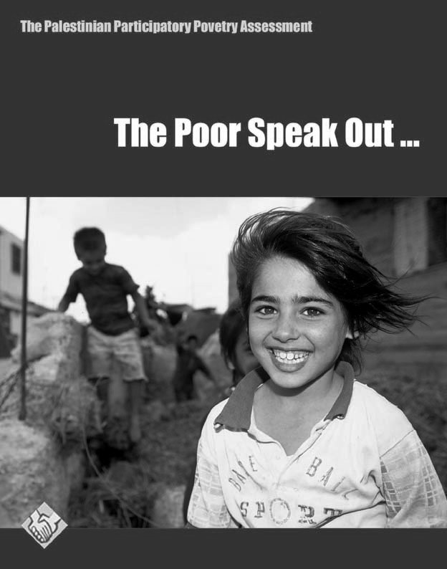 Source: PPA 2002 | The main object of the report was to understand the multi-dimensional nature of poverty and inclusion of the perspective and priorities of the poor in poverty analysis, and to increase local capacity to analyze and monitor poverty and policy impacts. The PPA report indicates that the poor are the "actual experts" in poverty as they are the ones who live it and thus governmental and civil organizations should listen carefully to their voices and learn from their wisdom. The report indicates that the poor are the outcome of economic and social systems, producing inequity and excluding certain groups from labor market depending on the market's determinants. Poverty production also relates to the prevalence of unequal power relations in the structure of the society itself or in regional and international relations.

The PPA report did not seek to map poverty in the OPT on the basis of selected quantitative variables according to statistical data, but rather it mainly aimed at identifying views of the poor themselves to their situation, its causes, and ways to escape their poverty. It also sought to record their opinions on services provided to them. It was also concerned with identifying how public institutions, NGOs and civil society organizations, at the level of localities (village, camp, and towns) and the District level, view the reality of poverty and ways to challenge it.

Palestinian Central Bureau of Statistics (PCBS) indicates that the percentage of Palestinian families living under the poverty line increased to more than 64% from the beginning of Second Intifada to April 2001, meaning that over two million Palestinians were living under the poverty line.
According to the World Bank’s worst-case scenario for the region, using a poverty line of US$ 2.1 per day, poverty would increase to 60% in 2002. The UNESCO estimated that the 60% rate had already been reached, with levels at approximately 55% in the West Bank and 70% in the Gaza Strip (UNESCO, 2002).

Poverty National Survey (PNS) was carried by the PCBS during December 2003, to have a quick accurate picture of expenditure and consumption poverty since the start of the second Intifada in September 2000. According to the survey, 40% of the population had a per capita consumption below the official poverty line.

In addition to poverty estimates, other studies quantify other poverty-related concepts. Using focus groups and interviews, the FAO estimated that 40% of the Palestinian population did not have food security as of March 2003. Food security refers to “physical, social and economic access to sufficient, safe, and nutritious food” (FAO and WFP, 2003).

In December 2004, the World Bank and the PCBS issued a report entitled "Deep Palestinian Poverty in the Midst of the Economic Crisis". This report attempted to clarify the debate, by providing estimate of the poverty and discussing some of the reasons why estimate vary. It also addressed the factors of cause of poverty, the impact of emergency assistance efforts on poor and potential impacts of an economic recovery on longer-term poverty rates. The report focused on the situation of the poorest of the poor (those who fall into subsistence poverty).

Statistical monitoring of the "Socio-Economic Condition Report- 2004" prepared by the PCBS, indicated that the poverty rate among Palestinian households in the OPT has continually increased. According to the report, 66% of the Palestinian households (2,682,000 people) fell under the poverty line in the first quarter of 2004. Compared with the third quarter in 2003 this number had increased by 3.7 % (2,456,000 people) (see Table 5).

Table 5: Households and population distributions blow the poverty line by region, Quarter 2/2003, Quarter 3/2003 & Quarter 1/2004
Area | Poorer |  |  |  |  |  | % Changes in poor households between Q3/2003-Q1/2004
Area | Q2 / 2003 |  | Q3 / 2003 |  | Q1/ 2004 |  | % Changes in poor households between Q3/2003-Q1/2004
Area | Hous-ehold % | Population | Hous-ehold % | population | Hous-ehold % | population | % Changes in poor households between Q3/2003-Q1/2004
Palestinian Territory | 63.3 | 2,483,000 | 62.3 | 2,456,000 | 66.0 | 2,682,000 | + 3.7
West Bank | 53.7 | 1,380,600 | 51.8 | 1,324,000 | 61.6 | 1,590,000 | + 9.8
Gaza Strip | 83.6 | 1,102,400 | 83.4 | 1,132,000 | 75.8 | 1,092,000 | - 7.6
Source: PCBS, Statistical Monitoring of the Socio-economic Condition Report- 2004

The PCBS report showed that 31.8% of Palestinian households depended on private sector salaries and wages as a main source of income during the first quarter of 2004: 12.1% of the households depended on family businesses, and 18.3% depended on salaries from the public sector.

The Third Quarter-2005 Economic and Social Monitor Report prepared by Palestine Economic Policy Research Institute (MAS), highlighted poverty in the OPT by locality type. The report revealed that Palestinian refugee camps have the highest rate of spread of poverty. Three out of ten refugee camp, households suffered from poverty (31.6%). This is considered the highest rate compared with 24.4% in urban areas and 24.6% in rural areas. The reason for the high rate of poverty in refugee camps may attribute to high unemployment rate, high dependency rate and large family size, compared with urban and rural areas. Urban areas have the highest percentage of poor (50.8%), followed by rural areas (29.7%) and refugee camps (19.5%) (see Table 6).

Table 6: Percentage of poverty by actual monthly consumption pattern for households by locality type (2004)
Locality Kind | Poverty |  | Poverty Gap |  | Severity of Poverty |  | Cute Poverty
Locality Kind | Value | Partici-pation | Value | Partici-pation | Value | Partici-pation | Value | Partici-pation
Urban | 24.4 | 50.8 | 6.6 | 52.7 | 4.0 | 54.3 | 16.2 | 52.5
Rural | 24.6 | 29.7 | 5.9 | 27.2 | 3.2 | 25.2 | 14.2 | 26.6
Camps | 31.6 | 19.5 | 8.4 | 20.1 | 5.0 | 20.5 | 21.6 | 20.8
Source: MAS, Economic & Social Monitor, third quarter -2005

All the studies describe the dramatic increase in poverty in the OPT since the start of the Second Intifada in 2000. It is shown that the major causes of this dramatic increase in poverty rate are tightened border closures both within the OPT and with the rest of the world, higher unemployment, rates and an expansion of the informal sector. Analysis calculation data demonstrates that Israeli policies of tightened bordered closures, house demolitions, and destruction of property have all contributed towards increasing levels of poverty, especially in the Gaza Strip. As poverty rates have increased, Palestinian households have adopted various coping strategies, the most common being transfers within households and relatives.

4. Corruption and poverty

Corruption is one of the main causes of poverty in the OPT. In spit of the fact that the Israeli Occupation is the main cause of poverty in OPT the PNA corruption and favouritism are also other contributors in the poverty in the OPT.

The PNA had long been plagued with corruption. However, according to the World Bank, it has made significant progress to tackle corruption and improve governance in recent years.

According to Palestinian Public Perceptions (PPP), 2006 perception, the majority of respondents (70%) think that corruption definitely exists in PNA, a similarly high percentage of respondents believe in the existence of significant and widespread corruption in the private sector (63%) and in civil society institutions (61%). On the other hand the perception indicate a high percentage of respondents (46%) believe that there is little corruption in the international organization working in the OPT.

The Coalition for Accountability and Integrity (AMAN) and the Palestinian Center for Political Studies and Surveys conducted in December 2004 an Opinion Poll in the OPT, regarding the phenomenon of nepotism and favouritism.

The poll revealed the impressions of the general public regarding favouritism, bribery and nepotism. It is like this: 52% of those surveyed stated that favoritism and nepotism are the most common form of corruption in the Palestinian society. The youth in particular (especially those who are single), the educated (especially those with a B.A. degree), the poor, the marginalized, and people with low income, shared the same opinion. As to the bribery, 22% of those surveyed believed that bribery is the most common form of corruption. .

5. Palestinian Poverty Profile in 2005

In June 2006, the PCBS published a report on the state of poverty in the OPT for the year 2005. Poverty statistics in the report was based on the official definition of poverty developed in "Poverty Report 1998". The results presented are based on the data from the sixth Palestinian Expenditure and Consumption Survey (PECS-IV), used monthly consumption levels rather than monthly income. Two poverty lines were developed according to actual spending patterns of Palestinian families. The relative poverty line in the OPT for the reference household in 2005 stood at NIS (New Israeli Shekels) 2,143 (US$ 477), whereas the deep (absolute) poverty line stood at NIS 1,732 (US$ 385).

Poverty by region

The report indicated that 29.5% of Palestinian households experienced poverty in 2005. Of these households, 22.3% were in the West Bank and 43.7% in the Gaza Strip. 51.5% of households were found to secure an income less than the ascribed national poverty line in 2005. Of these 45.7% were in the West Bank and 63.1% in the Gaza Strip.

By locality type, refugee camps have the highest incidence of poverty overall. The report indicated that poverty in refugee camps was 39.9%, while it was 24.9% in urban areas and 32.5% in rural areas. A greater proportion of the poor live in urban areas (46.5%) and rural areas (32.5%) than in refugee camps (21.4%).

Poverty by household size

The highest poverty rate, (67.5%), was found to affect the largest households (10 or more members). The report also show that poverty increases consistently with additional numbers of children in a household. Households with 1-2 children represent 19.5% of the poorest Palestinians, 39% for households with 5-6 children, 53.6% for households with 7-8 children.

Poverty by head of household (gendering poverty)

According to the report, 6.8% of households headed by women are poor. These represent 25% of households operating below the poverty line. Male headed households represent 29.8% of the poorest Palestinians. Discrepancies between male and female headed households may be due to female householders being the highest recipients of public support and assistance.

Refugee status of head of household

Households maintained by refugee heads constitute about 41.1% of Palestinian households in 2005. Yet, they constitute about 47.8% of the poor. Living conditions of this group are worse compared with the other groups in both the Gaza Strip and the West Bank.

Educational level of head of household

Education of head of household is negatively associated with incidence of poverty. The poverty rate for those obtained less than elementary education (41.4%) was almost two and half times higher than those with a two-year college degree (16.9%), and almost four times higher than those with a university degree and above (9.6%). Poverty decreases consistently with educational level when other measures of poverty are used.
The report showed an increase in poverty during the Second Intifada. Results indicated that poverty affected 29.5% of the population in 2005, compared with 20.3% in 1998; an increase of 9.2% (see Table 7).

Table 7: Poverty according to monthly consumption patterns of households, (1998-2005)
Indicator | 1998 | 2001 | 2004 | 2005 | % Changes between 1998 and 2005
Poverty Rate | 20.3 | 27.9 | 25.6 | 29.5 | 45.3
Deep Poverty | 12.0 | 19.5 | 16.4 | 18.1 | 50.8
Poverty Gap | 5.5 | 7.6 | 6.6 | 8.0 | 45.5
Poverty Severity | 3.0 | 5.0 | 3.9 | 4.4 | 46.7
Source: PCBS, 2005

6. Poverty, the human cost of closures in 2006

Since March 2006, the deteriorated economic conditions of the OPT had worsened, following the election of the new Palestinian Government formed by the Islamic Resistance Movement (HAMAS) based on the absolute majority achieved in the Palestinian legislative elections.

These political and financial closures on the Palestinian people and Government have plunged the Palestinian economy into deep crises, causing dramatic declines in living standards. The loss of these income sources and the reluctance of banks to transfer funds to the PNA have seriously undermined the functioning of its institutions. This crises was caused primarily by Israeli Occupation polices, which include economic and social strangulation, threatening Palestinian livelihood and obstructing the movement of medicines and food, including nutrition for anaemic children, vaccines, medications for pregnant women, elderly and chronic patients (Palestinian Centre for Human Rights, 2006).

Situation is complicated further by the PNA's inability to pay the salaries of civil servants. PNA revenues have dropped by 75% compared with 2005. Salaries of 160,000 PNA's employees have not been paid since March 2006. The monthly budget of the PNA is estimated at US$ 165 million a month. Approximately 60% of this budget goes to salaries, supporting the livelihoods of about one million Palestinians. Survey data indicates that after only two months of going without salaries, the PNA employees have grown poorer more quickly than the general population (World Bank, 2007).

The World Bank indicated in that time, that if the situation persists, poverty was expected to increase to about 74%. In addition, per capita income is expected to decline a further 25% below the 2005-level. This is a call to donor countries to stop imposing collective punishment on the Palestinian people and to enact the principles of International Humanitarian Law, especially the Fourth Geneva Convention of 1949 relevant to the protection of civilians at times of war. In addition, it is a call to those countries to enact the principles of International Human Rights Law and regional conventions on human rights, including the EU Association Agreement with the government of Israel.

Depending on the survey of the impact of Israeli procedures on the socioeconomic conditions of the Palestinian households for the second quarter of 2006, the PCBS estimated poverty rates at 65.8% among Palestinian households, (PCBS, 2006). On other hand, the results of the survey showed that 87.7% of the Gaza Strip households were suffering from poverty, whereas the rate was 54.6% in the West Bank.
The Gaza Strip (87.7%) and south West Bank (69.2%) households are the most vulnerable regions comparing with the others, followed by households of the North West Bank governorates (60.1%) comparing with the households of Middle West Banks governorates (34.2%) (see Map 2).

Map 2: Poverty rate in the OPT, (May 2006)
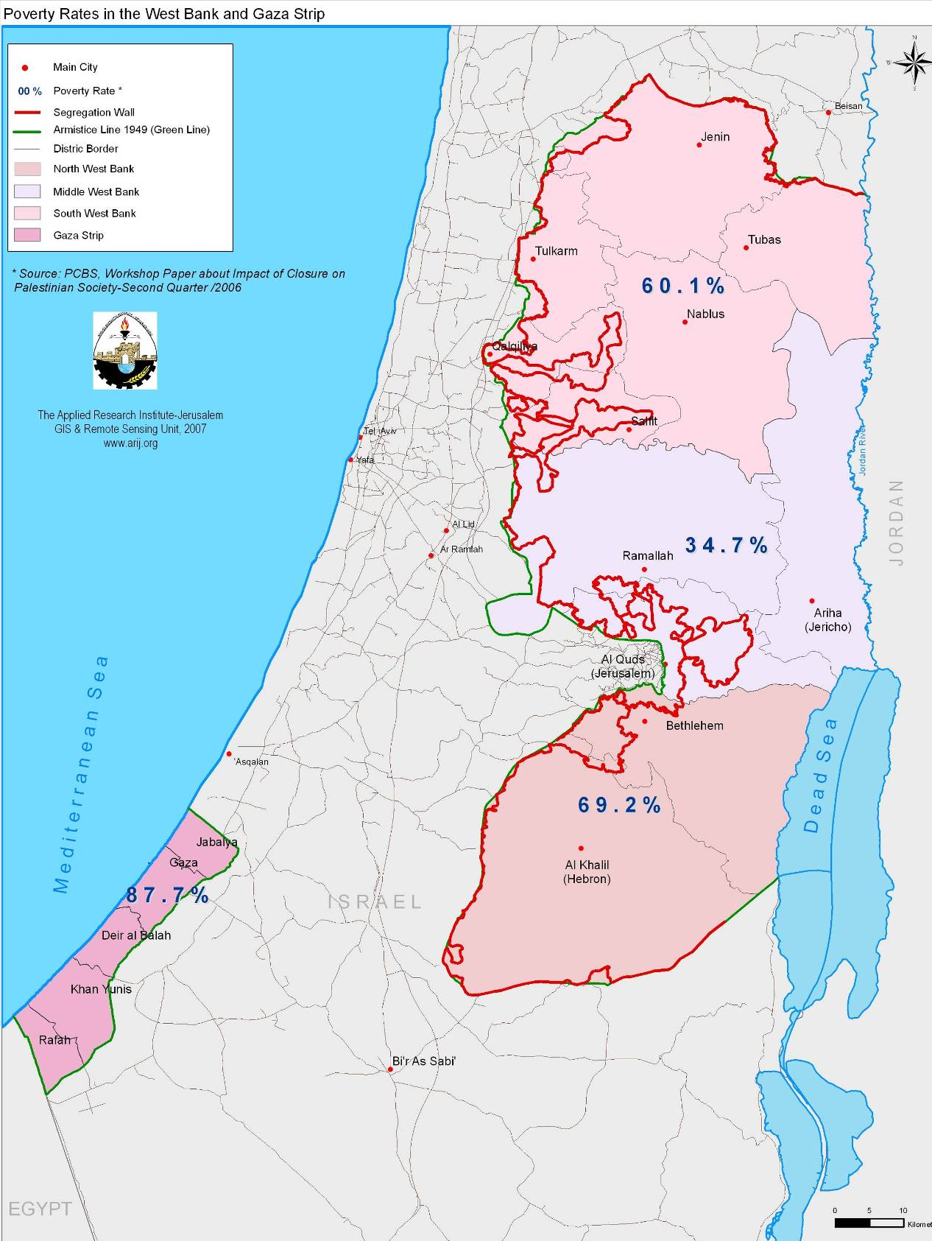
Source: ARIJ, GIS Unit, 2007
Refugee camps households have the highest incidence of poverty overall compared with households in urban and rural areas. Eight households out of ten in refugee camp suffered from poverty (76.3%). This is higher than the rate of poverty in the urban areas (62.3%) and rural areas (67.4%).

The Impact Survey indicated that the highest poverty rate was for the largest households. The poverty rate for the largest households (with 10 persons or more members) are 1.7 twice poverty rates of the households with 2-3 persons, 1.6 twice of the households of 5-6 persons, and 1.3 twice of households of 6-7 persons.

The result of the survey showed that the situation of the poor households headed by women is better than those headed by men. Households headed by females have lower poverty rate (60.7%) than males headed households (66.3%).

Increasing poverty

‘Three months ago my shop closed. I could not continue because the debts of my customers became too great. This is the responsibility of the siege (financial sanctions) of the Palestinian government Most of the villagers have not paid me the money they owe me. I sold my wife’s jewellery to open my shop, now I have lost everything.’- Oxfam International-2007

By November 2006, according to the World Bank, the incomes of PA workers had fallen to 40% of their normal levels over the previous year, and wage arrears had soared to over half a billion dollars. A November 2006 poll of government workers showed an increase in poverty from 35% to 71%.
An Oxfam survey of 677 household heads across the West Bank and the Gaza Strip, conducted in mid-March 2007, 87% of people interviewed in Gaza and 81% in the West Bank said that their household income had been reduced. In Gaza, 53% said that their household income had fallen by more than a half, and 21% said their household income had stopped altogether. Households have resorted to borrowing, selling possessions, reducing healthcare and food consumption, and taking children out of school (Oxfam International, 2007).

7. Growing international aid, greater poverty

Despite the suspension of aid to the PNA, aid to the OPT reportedly increased during 2006. Assistance was provided through channels outside the PNA, particularly the United Nations Relief and Works Agency (UNRWA). Some estimates suggest that total aid to the OPT increased from US$ one billion in 2005 to US$1.2 billion in 2006. The IMF estimates that US$ 747 million was provided for recurring government expenditures in 2006, more than double the amount of budgetary support given in 2005. The World Bank estimates that GDP would have fallen a further 10% without this additional assistance. Why, then, has poverty climbed so sharply during the same period?

First, international aid does not compensate for the substantial loss of income created by the withholding of at least US$ 475 million of Palestinian tax and customs revenues by Israel.

Second, Palestinian workers and welfare recipients have spent months without any direct assistance. Many elements of the TIM are only just becoming operational, and some workers received their first TIM payments only in late 2006 or early 2007.
Third, part of the increase in international aid is accounted for by humanitarian assistance, which, while necessary, does not generate income or offer the same long-term benefits as development aid. In 2005, 16% of EU aid was spent on humanitarian assistance. In 2006, this had risen to 56%.

Fourth, international aid has become increasingly fragmented and unaccounted for, making it difficult for donors to target assistance effectively (Oxfam International, 2007)

8. Food Security Status of Palestinian people and poverty

“Food security here is a special case…. We can be starving one day because there is no supply of food, and we can have more food than we ever need on another because we can freely fish and cultivate our lands and go to work….Food security to us is mostly related to the political situation…. We are food secure if the Israelis leave us alone and stop trying to make our lives into a nightmare. If they do that then we can be food secure because we can earn a living, cultivate our lands, raise our animals, eat fish and import food as we desire.”
participant in a Focus Group discussion – Gaza Strip WFP, FAW- 2007

In 2007, World Food Programme and Food and Agriculture Organization (WFP/FAO) issued Comprehensive Food Security and Vulnerable Assessment (CFSVA, 2006) to update and expand a comprehensive approach to food security –including peoples' own perceptions, socioeconomic statistics, income, expenditure and consumption statistics, food traders' study, and a nutrition review.

The CFSVA concluded that 34% (1,322,019) of the population of the OPT is food insecure, 12% (466,595) is vulnerable to becoming food insecure, 20% (777,658) is marginally secure, and 34% (1,322,019) is food secure (Table 7). Although the 2003 FAO/WFP Food Security Assessment used a different methodology, the findings were quite similar. The 2003 study concluded that four out of ten Palestinians (40%) were food insecure and 30% more were at risk of becoming food insecure, given the conditions at that time (Table 8).

Table 8: Food security groups: frequencies and descriptors
Food Insecure | Vulnerability to Food Security | Marginally Secure | Food Security
34% | 12% | 20% | 34%
- Households with income and consumption below 1.6$/capita/day.  - Households showing decrease in total, food and non-food expenditures, including households unable to further decrease their expenditure patterns | - Households showing both income and consumption below 2.2$/ cabita /day EXEPT households showing no decrease in expenditure patterns (categorised as marginally secure) | - Households showing either income OR consumption above $2.2/cabita/day (not booth).  - Households with both income and consumption between $1.6 and $2.2/cabita/day but show no decrease in expenditure patterns. | - Households with income and consumption above $2.2/ cabita /day.  - Households with income or consumption above between $ 1.6 and $2.2/capita/day but showing no decrease in total, food and non-food expenditure
Source: Comprehensive Food Security and Vulnerability Analysis (CFSVA-2007)

The absolute number of people in need of assistance to meet their food requirements in a sustainable manner is growing as the population increases. The large-scale assistance received by Palestinians in different modalities and through different channels is supposed to have cushioned the humanitarian impact of the livelihood crisis. Since February 2006, new population groups have become food insecure (or more food insecure) in addition to the pre-existing food insecure groups. For example, families supported by PNA employees are drastically affected by the transitory suspension of salary payments. This is partially offset by allowances received through the Office of the President that are sourced from Temporary International Mechanism (TIM) and Arab donors.

Source: PPA, 2002 | Analysis on the food security profiles by refugee status showed that the depth of food insecurity is lower among the non-refugee population than among refugees:  - Out of the total 34% of the population residing in the OPT who are classified as food insecure, food insecurity among non-refugees is 30% while it is 40% for refugees demonstrating that the severity of food insecurity is higher for the latter group.  - 24% of food insecure non-refugees are located in the West Bank and 58% are located in the Gaza Strip. Furthermore, 40% (237,088) of those described as food insecure are highly dependent on food aid (table 9).

Table 9: Food security classifications by refugee statues
 | Non-Refugees | Refugees | Total
Food Insecure | 30.1 | 39.7 | 34.3
Vulnerable | 11.6 | 11.7 | 11.7
Marginally Secure | 19.8 | 19.5 | 19.6
Food Secure | 38.5 | 29.1 | 34.4
Total | 100 | 100 | 100
Source: Comprehensive Food Security and Vulnerability Analysis (CFSVA, 2007)

Finally, it is worth mentioning that 46% of the Palestinian population are children (0-14 years), who are typically more vulnerable to food insecurity nutritional outcomes.

9. The Segregation Wall and its impact on poverty

The Israeli disengagement process in the Gaza Strip and the construction of the Segregation Wall around the West Bank both have had negative impacts on Palestinian socio-economic conditions. Despite the fact that the Wall is not yet completed, its effect on the Palestinian people has become manifest in the forms of migration, unemployment, loss of land and poverty, in addition to restrictions on movement and that have badly affected social relations. The wall has also led to reduced access of emergency services, and negatively impacted the quality of education

The construction of the Segregation Wall, which was initiated in June 2002, continued in the central and southern regions of the West Bank. About half of the 725-km Wall has been completed (ARIJ-GIS, 2007). The Wall’s current route will end up including 10.1% of the West Bank and East Jerusalem, in the area lying between the Wall and the Green Line.
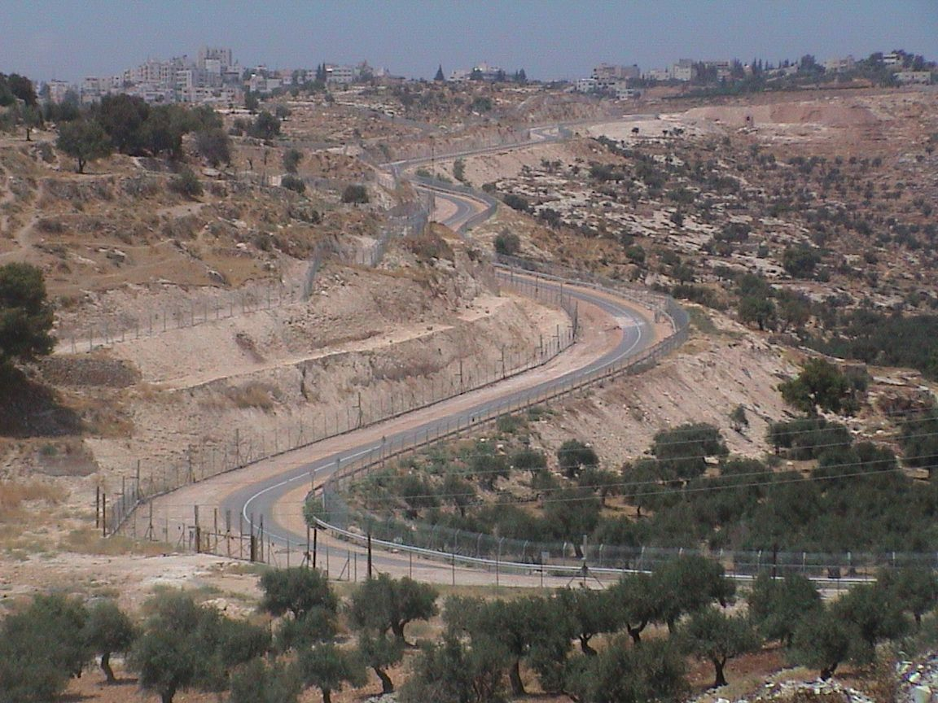  The segregation Wall , Source: ARIJ Photos, 2006 | 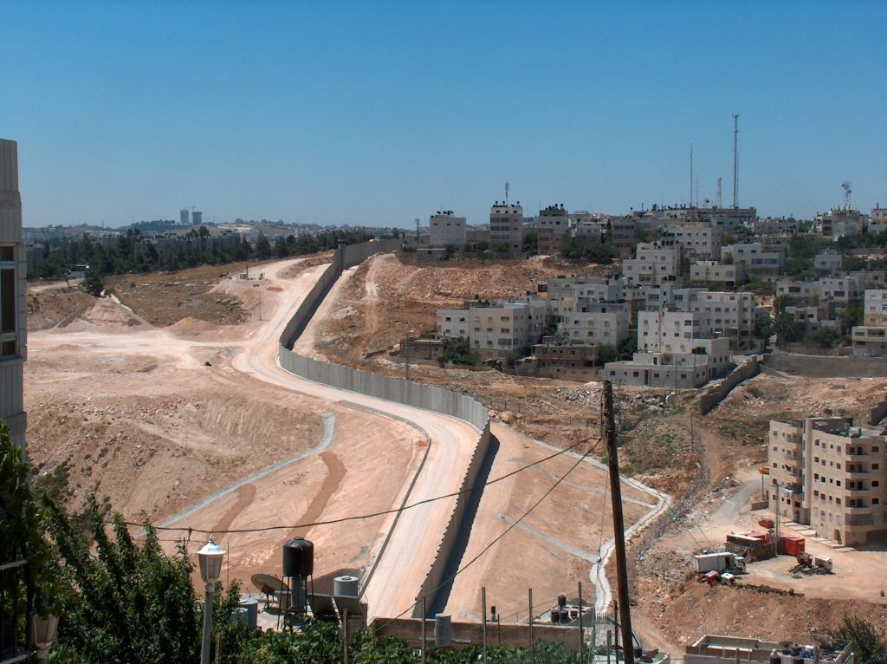

In August 2006, the PCBS conducted the last round of surveys of the surveillance system to monitor the impact of the Israeli measures on the well-being of the Palestinian people. The following are the main socio-economic results of the survey:

Movement

The percentage of individuals whose movement has been restricted as a result of time spent travelling is 82.9% in localities inside the Wall in August 2006 and 56.5% in the localities outside the Wall in the same period.

Land confiscation

16.6% of households living in localities inside the Wall have had experienced complete land confiscation as compared to 19.3% for households living in localities outside the Wall. It should be noted that most confiscated land in localities affected by the Wall were previously used for agriculture.

Humanitarian aid

6.4% of households, or of individuals in localities affected by the wall, reported that they received humanitarian assistance during July 2006 (7.2% inside the Wall and 6.3% outside of the wall). The majority of assistance was provided in the form of food supplies; 23.9 % was in cash.

Income sources

25.6% of households living in the localities affected by the Wall depended on wages and salaries from Palestinian private sector as a main income source before the construction of the Wall, against 32.5% depending on this source after the construction of the Wall. In addition, before the construction of the Wall 38.9% of households living in localities affected by the Wall depended on wages and salaries from the Israeli labour market, compared with 21.7% depending on the same source following construction of the Wall. The results also show that 20.3% of households living in localities affected by the Wall depended on household projects before the construction of the Wall, against 21.8% depending on the same source after construction. 15.8% of households depended on wages and salaries from the national government before the construction of the Wall, against 17.9% depending on the same source after the construction. 23.9% of households depended on the agricultural sector before the construction of the Wall; against 20.2% depend on the same source after construction.

Labour market

32% of the labour force from localities affected by the Wall was unemployed, (23.4% inside of the Wall and 32.3% outside of the Wall). Most of the workers in the localities affected by the Wall received payment of some kind (69.5%), while the percentage of employers and self-employed workers amounted to 24.7%. The results also reveal that 17.1% of workers in localities affected by the Wall work in Israel and its settlements.

10. Who are the poor in the OPT?

Poverty definition involved a number of perceptions that have been repeatedly echoed in most communities in the OPT, as well as in the case studies which conducted by the PPA, (2002) with a large number of families in different areas of the West Bank and Gaza Strip. These perceptions can be classified under the following headings:
- Low and interrupted income and lack of job security: This is apparent in the perception that a poor family is the one where the provider is unable to provide adequate income to meet their basic needs, food, clothing and proper housing, ensuing treatment and education of family members, and paying electricity and water bills.
- Lack of abilities: Many of the poor considered chronic illness or disability as factors linked to poverty. Many repeatedly said, "The poor is one with poor mind," indicating the importance of proper training and planning for avoiding poverty.
- Traditions restricting women's freedom in terms of work, education and inheritance (i.e. not respecting the right to independent decision): The poor, especially women, link poverty with lack of abilities. This perception is considered as disappointing, negatively affecting women's active role in the society.
- Poverty as an expression of a refugee status, severe lack of public services or restricted public sphere: Some refugee camp residents consider poverty as "being a refugee or displaced".
- Connections and mediations as a cause of poverty for some people: unemployed graduates expressed severe disappointment from their situation, being compelled to work in jobs that do not suit their qualification or to remain unemployed. An unemployed young man says, "Today, any job requires having connections".
- Poverty for children and elderly people: Children are the group most sensitive to deprivation. For children, deprivation is expressed in different statements, such as "a father with no money and unable to give his children pocket money, buy them clothes or send them to school." The elderly also are among the groups most sensitive to poverty. Some feel bitterness as their children stopped caring for them.

How the poor view causes of their poverty and impoverishment? The following are main headings mentioned by the poor as causes of their poverty.
- Causes related to labor market's situation and conditions (reliance on the Israeli labor market, unemployment, wages and salaries): "Men are not having jobs."
- Israeli policies towards the Intifada as a cause of aggravating and expanding poverty: Many of the poor and lay people linked poverty to the continuous Israeli Occupation and measures, including collective punishment, closure of Israeli markets for Palestinian labor, and aggressions at individuals, communities and properties.
- Refugee status: Poor camps residents repeatedly stated that displacement of refugees in 1948 has been and continue to be the main cause of their impoverishment after they lost their properties and livelihood and suffered displacement. This refers to a state of dispossession due to the loss of homeland and coerced immigration.
- Lack of basic public services: Poverty causes include the lack of basic public services, especially in terms of roads, electricity, water and sanitation networks, as well as schools and health centers.
- Chronic illness, early marriage, and large family size, traditions of marginalizing the role of women: These factors were repeatedly mentioned as causes of poverty. Usually, early marriage, as well as polygamy, leads to large family size, crowding, improper housing, ill health and, consequently, poverty.
- Neglect and decline of agriculture: "Agriculture is not paying back". In addition to neglecting agriculture in favor of work in Israel and employment in the public sector, many people pointed out that agriculture is nor\t worthwhile.

Abstract

Since the outbreak of the second Palestinian Intifada in September 2000, and the 2006 election of a new Palestinian legislative council, political, economic, and social conditions have sharply deteriorated for the Palestinian people. Israeli imposed closure, the withholding of Palestinian customs revenues, and the freezing of international aid donations is prompting a climate of desperation amongst the democratically public.

The victims of these policies and procedures are, of course, the people. Poverty rates have risen significantly.

In light of these considerations, the paper will research the extent of poverty as a direct result of recent political events, as well as address means as to potential alternative alleviation of such problems. Data sources will include the Palestinian Central Bureau of Statistics (PCBS), World Bank reports, UNRWA data and reports, as well as field interviews with members of the public.

It is this paper’s aim to help improve understanding in the determining factors of poverty in order to better identify policies promoting poverty eradication.

References
- Applied Research Institute-Jerusalem, (ARIJ), ARIJ Data Base.
- Applied Research Institute-Jerusalem (ARIJ), 2007. The Geographic Information System Unit Database (JIS).
- Applied Research Institute-Jerusalem (ARIJ) 2007, The Status of the Environment profile in the OPT.
- Palestinian Central Bureau of Statistics (PCBS), Labour Force Survey -Annual Report: several issues. Ramallah.
- Palestinian Central Bureau of Statistics (PCBS), National Accounts at Current Prices (1994-2006). Ramallah.
- Palestinian Central Bureau of Statistics (PCBS), 2007. Press Release, preliminary Estimates of Quarterly National Accounts (Forth Quarter 2006) Ramallah.
- Palestinian Central Bureau of Statistics (PCBS), 2006. Palestinians at the end of year 2006. Ramallah.
- Palestinian Central Bureau of Statistics (PCBS), 2006. Poverty in the Palestinian Territory, 2005. Main finding report. Ram Allah.
- Palestinian Central Bureau of Statistics (PCBS) 2006, Work shop on Impact of closure on poverty in OPT.
- Palestinian Central Bureau of Statistics (PCBS) and World Bank (WB) October 2004, Deep Palestinian Poverty in the Midst of Economic Crises.
- Palestinian Central Bureau of Statistics (PCBS), 2007. Impact of the expansion and annexation Wall on the socioeconomic conditions of Palestinian household in the localities in which the Wall passes through, August, 2006.
- Palestinian Economic Policy Institute (MAS), 2005, 2006. Economic and Social Monitor. Volume (5, 6, 7). Ramallah.
- Ministry of Planning and International Cooperation (MOPIC), National Report on Participatory Poverty Assessment (PPA)-2002, Ramallah.
- Hadeel, and Qazaz and Nader, 1998. Poverty in Palestine. Ramalla.
- The Palestinian Center for Human Rights, poverty in the Gaza Strip, 2006.
- The Palestinian Center for human rights, poverty in the Gaza Strip, 2006.
- International Monetary Fund (IMF) – the World Bank (WB), West Bank and Gaza economic developments in 2006- a first assessment, March 2007.
- International Monetary Fund (IMF), Macroeconomic Developments and Outlook in the West Bank and Gaza, 2005.
- WFP/FAO- West Bank and Gaza Strip, Comprehensive Food Security and Vulnerability Analysis –CFSVA -2007.
- Oxfam International- Poverty in Palestine: the human cost of the financial boycott, 2007.
- World Bank Technical Team, Movement and Access Restrictions in the West Bank: Uncertainty and Inefficiency in the Palestinian economy, 2007.
- Fighting Palestinian poverty, A survey of the economic and social impact of the Israeli occupation on the Palestinians in the West Bank and Gaza Strip 2004.
- International Monetary Fund – the World Bank, West Bank and Gaza economic developments in 2006- a first assessment, March 2007.
- World Bank, Poverty in the West Bank and Gaza, January, 2001-Middle East and North Africa Region.
- United Nation University (WIDER), Economic Aspects of the Palestinian-Israel Conflict- the Collapse of the Oslo Accord Fadle M. Naqib, 2002.
- World Bank, 2007 West Bank and Gaza public expenditure review valium 1.
- Palestine Research Unit (PRU), Palestinian Public Perceptions (PPP), Report IX- April 2006.
- Applied Research Institute-Jerusalem: <http://www.arij.org> .
- Palestinian Central Bureau of Statistics (PCBS) <http://www.pcbs.org>
- Office for the Coordination of Humanitarian Affaires (OCHA) <http://www.ochaopt.org/

The term “closure” is a set of measures and restrictions that have been practiced on land by the Israeli Occupation since 1994 and during Al-Aqsa Intifada, (Uprising) which affected and impeded the movement of Palestinian persons and goods between Palestinian governorates or between Palestinian Territory and other countries. However, Israeli closure policy (total or partial) of all boarder points was and remain a major obstacle.
Started on 28 September 2000, by Palestinian youth demonstrating against the Israeli Occupation when Ariel Sharon (former Israel's Prime Minister and leader of the right-wing party - the Likud), made a provocative visit to the Haram Al-Sharif (the Noble Sanctuary), in Jerusalem, accompanied by 1,000 Israeli police.
New Israeli Shakle (nis), Which is considered the main payment currency in OPT (which has no national currency)
The first Palestinian Intifada (Uprising), erupted in December 1987 and continued intermittently till the signing of the Oslo Accord in 1993, it was one of the important political factors that led to the negotiation between Palestinian Liberation Organization and Israel in Oslo.

